**P5 - Modify images as a result of user feedback**

**Introduction**

In this assignment, I will be reflecting on the images and my peers will be reviewing my logo and work. They will give me feedback of what to do and what to change for it. After, I will be changing these requested ideas and I will be giving steps of how I did it. Screenshots will be present for proof.

**User Feedback Table**

|  |  |  |  |  |
| --- | --- | --- | --- | --- |
| Product | Aspect | User Comments | Change Requested | Change Made |
| Web image promotional pictures | Add a slogan | It looks plain and needs a slogan to make it look better | “Life is bright”  Add it | Yes |
| Poster  (FOOTBALL) | Logo | Add an Arsenal logo | It looks plain and arsenal logo would fit in perfect | Yes |
| Poster  (TRANSFORMERS) | Tail of the dragon | It is cut out and needs to be fixed | It would be perfect with the tail fixed | Yes |
| Poster  (CONCERT) | Price  Who is on the going to be on the concert | Add the price of the tickets and who is going to be in the concert | The customers would know who is going and how much | Yes |

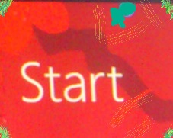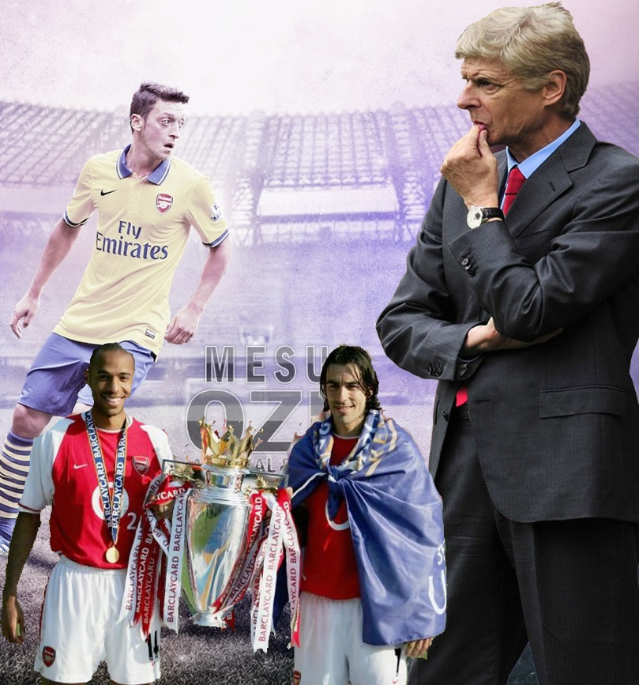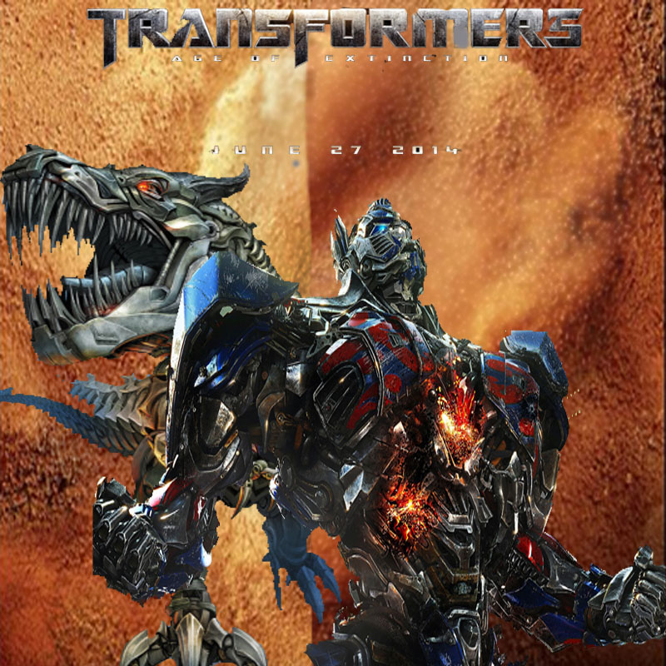**BEFORE POSTERS AND LOGOS**



**CHANGE REQUESTED PROCESS**

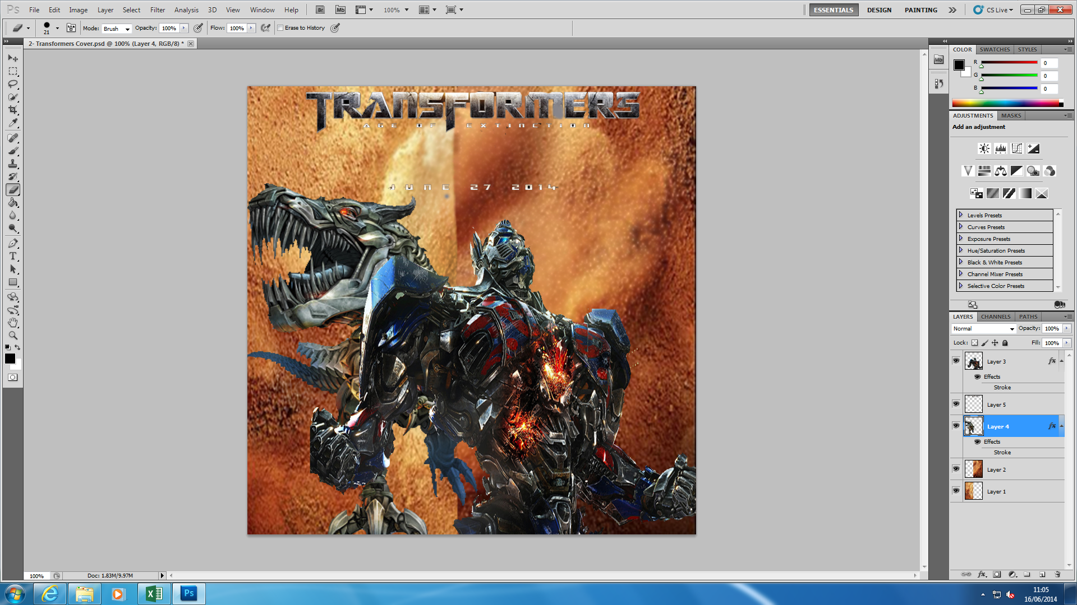

As you can see the request has been changed. I used the eraser tool and shrieked the size of the tool and changed both of them. It looks much better now than it did before.

The tools that I used:

* Eraser Tool

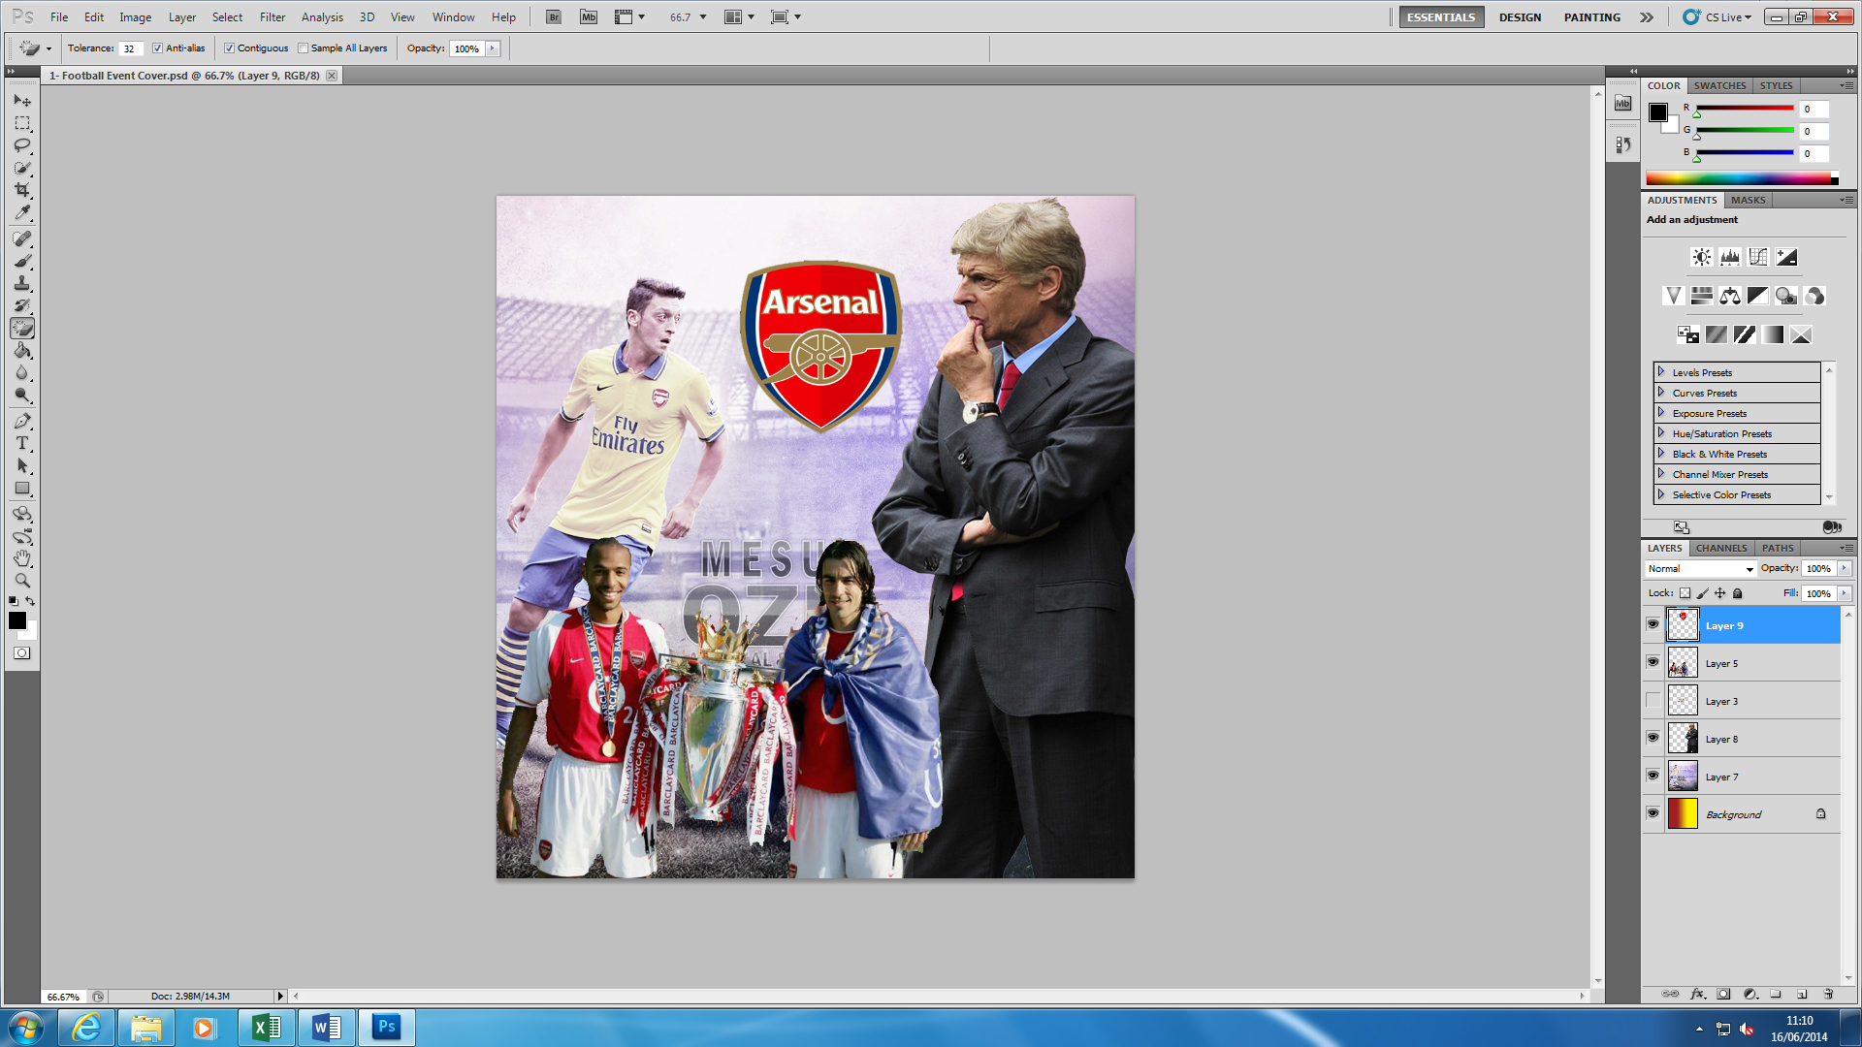

As you can see the request has been changed. I added a logo as request. Once I pasted the logo, it had a black background. I erased it by using the magic tool and saved it. Also, it was large once it had been pasted. I pressed CTRL + T and shrieked it to the size that I wanted.

The tools used:

* Magic Eraser Tool
* Move Tool
* CTRL + T to shrink it

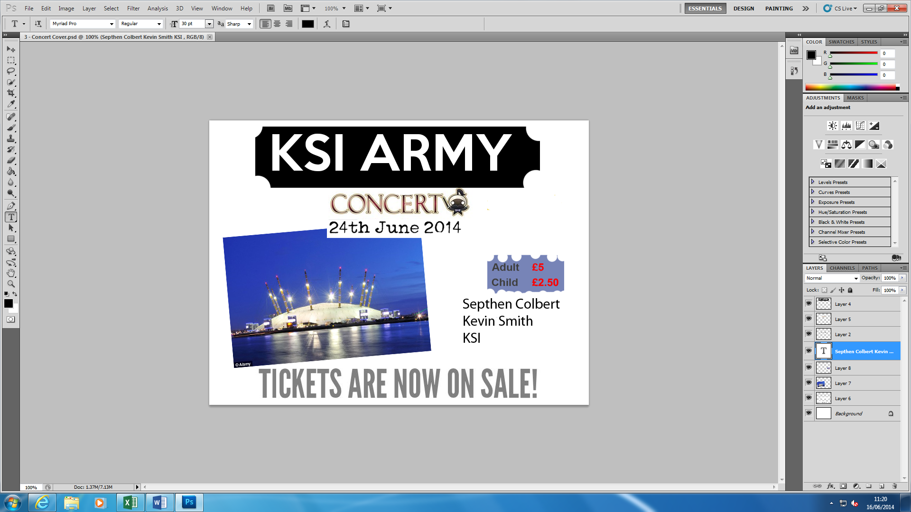

These are the changes that I have managed. I added the price and who is going to go to this concert.

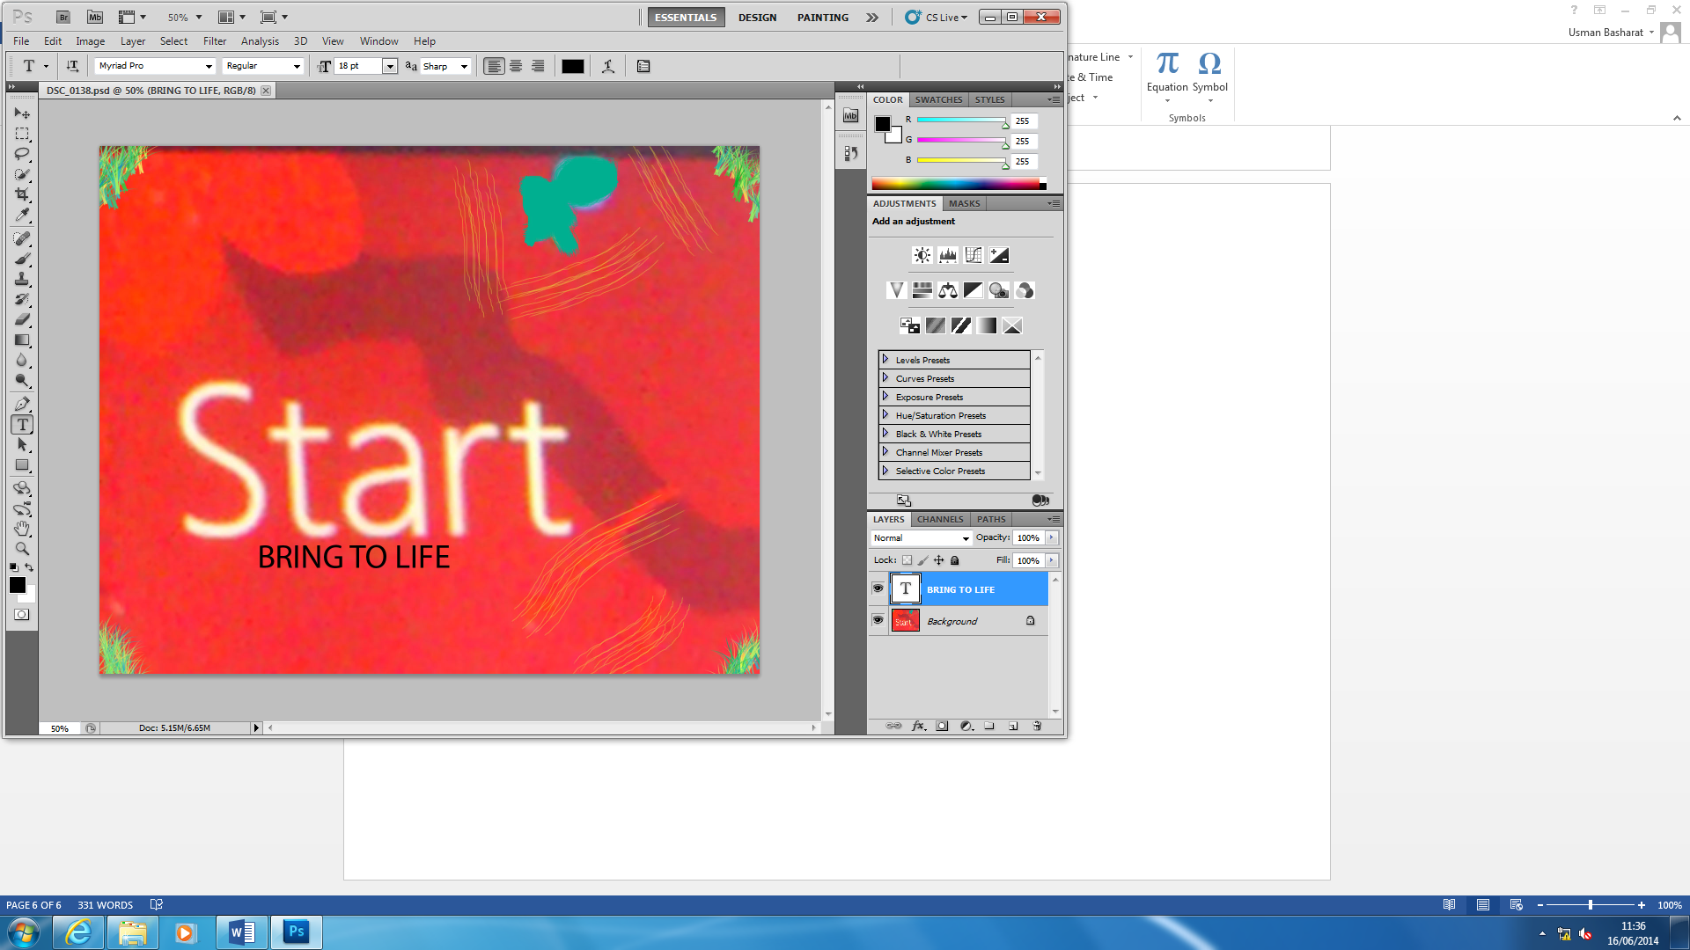

This is the change. I simply added the ‘Bring to life’ into the logo and make that as a slogan.

The tools that I used:

* Writing tool